Updated Vitamin D Analysis

Tim Vigers & Laura Pyle

04 March 2019

Table 1a: Descriptive statistics for full cohort.

|  |  |
| --- | --- |
|  | Overall |
| n | 80 |
| sex = M (%) | 40 (50.6) |
| race = Other (%) | 20 (25.0) |
| free.vd (median [IQR]) | 4.40 [2.90, 5.73] |
| total.vd (median [IQR]) | 19.05 [12.40, 21.70] |
| pth (median [IQR]) | 10.55 [7.60, 14.17] |
| age (median [IQR]) | 11.40 [6.10, 15.12] |
| dm_week (median [IQR]) | 6.75 [3.68, 10.75] |
| a1c (median [IQR]) | 8.20 [7.15, 9.25] |
| bmi (median [IQR]) | 18.35 [16.20, 21.50] |
| vdbp (median [IQR]) | 0.01 [0.00, 0.02] |

Table 1b: Descriptive statistics by antibody group. High Ab defined as >= 0.02 units.

|  |  |  |  |  |
| --- | --- | --- | --- | --- |
|  | High | Low | p | test |
| n | 17 | 63 |  |  |
| sex = M (%) | 7 (43.8) | 33 (52.4) | 0.736 |  |
| race = Other (%) | 3 (17.6) | 17 (27.0) | 0.540 | exact |
| free.vd (median [IQR]) | 5.50 [1.40, 6.60] | 4.30 [2.95, 5.35] | 0.314 | nonnorm |
| total.vd (median [IQR]) | 21.20 [1.60, 24.40] | 18.60 [12.75, 21.25] | 0.549 | nonnorm |
| pth (median [IQR]) | 10.40 [7.60, 13.70] | 10.60 [8.20, 14.25] | 0.787 | nonnorm |
| age (median [IQR]) | 5.10 [2.90, 10.90] | 12.10 [10.25, 16.15] | 0.003 | nonnorm |
| dm_week (median [IQR]) | 6.60 [3.40, 15.00] | 6.90 [3.80, 9.20] | 0.746 | nonnorm |
| a1c (median [IQR]) | 8.10 [6.80, 8.50] | 8.35 [7.30, 9.30] | 0.337 | nonnorm |
| bmi (median [IQR]) | 16.80 [15.10, 18.60] | 18.80 [16.40, 22.05] | 0.083 | nonnorm |

Figure 1: Spearman correlations between PTH and vitamin D (free and total)

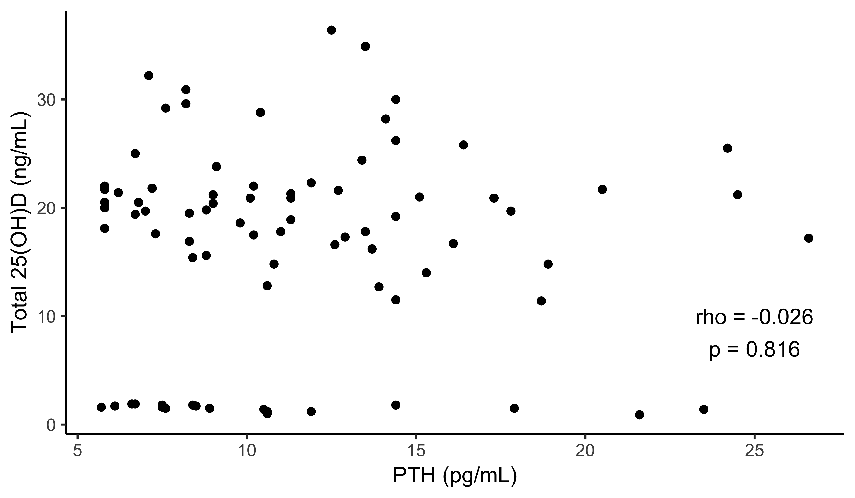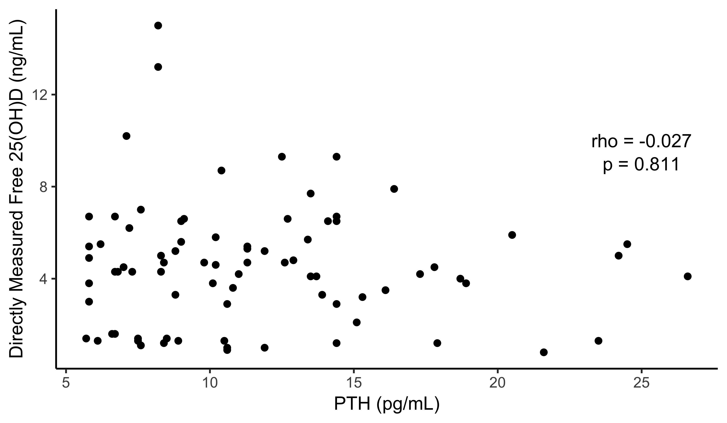

Figure 2: Spearman correlations between AB concentration and vitamin D (free and total)

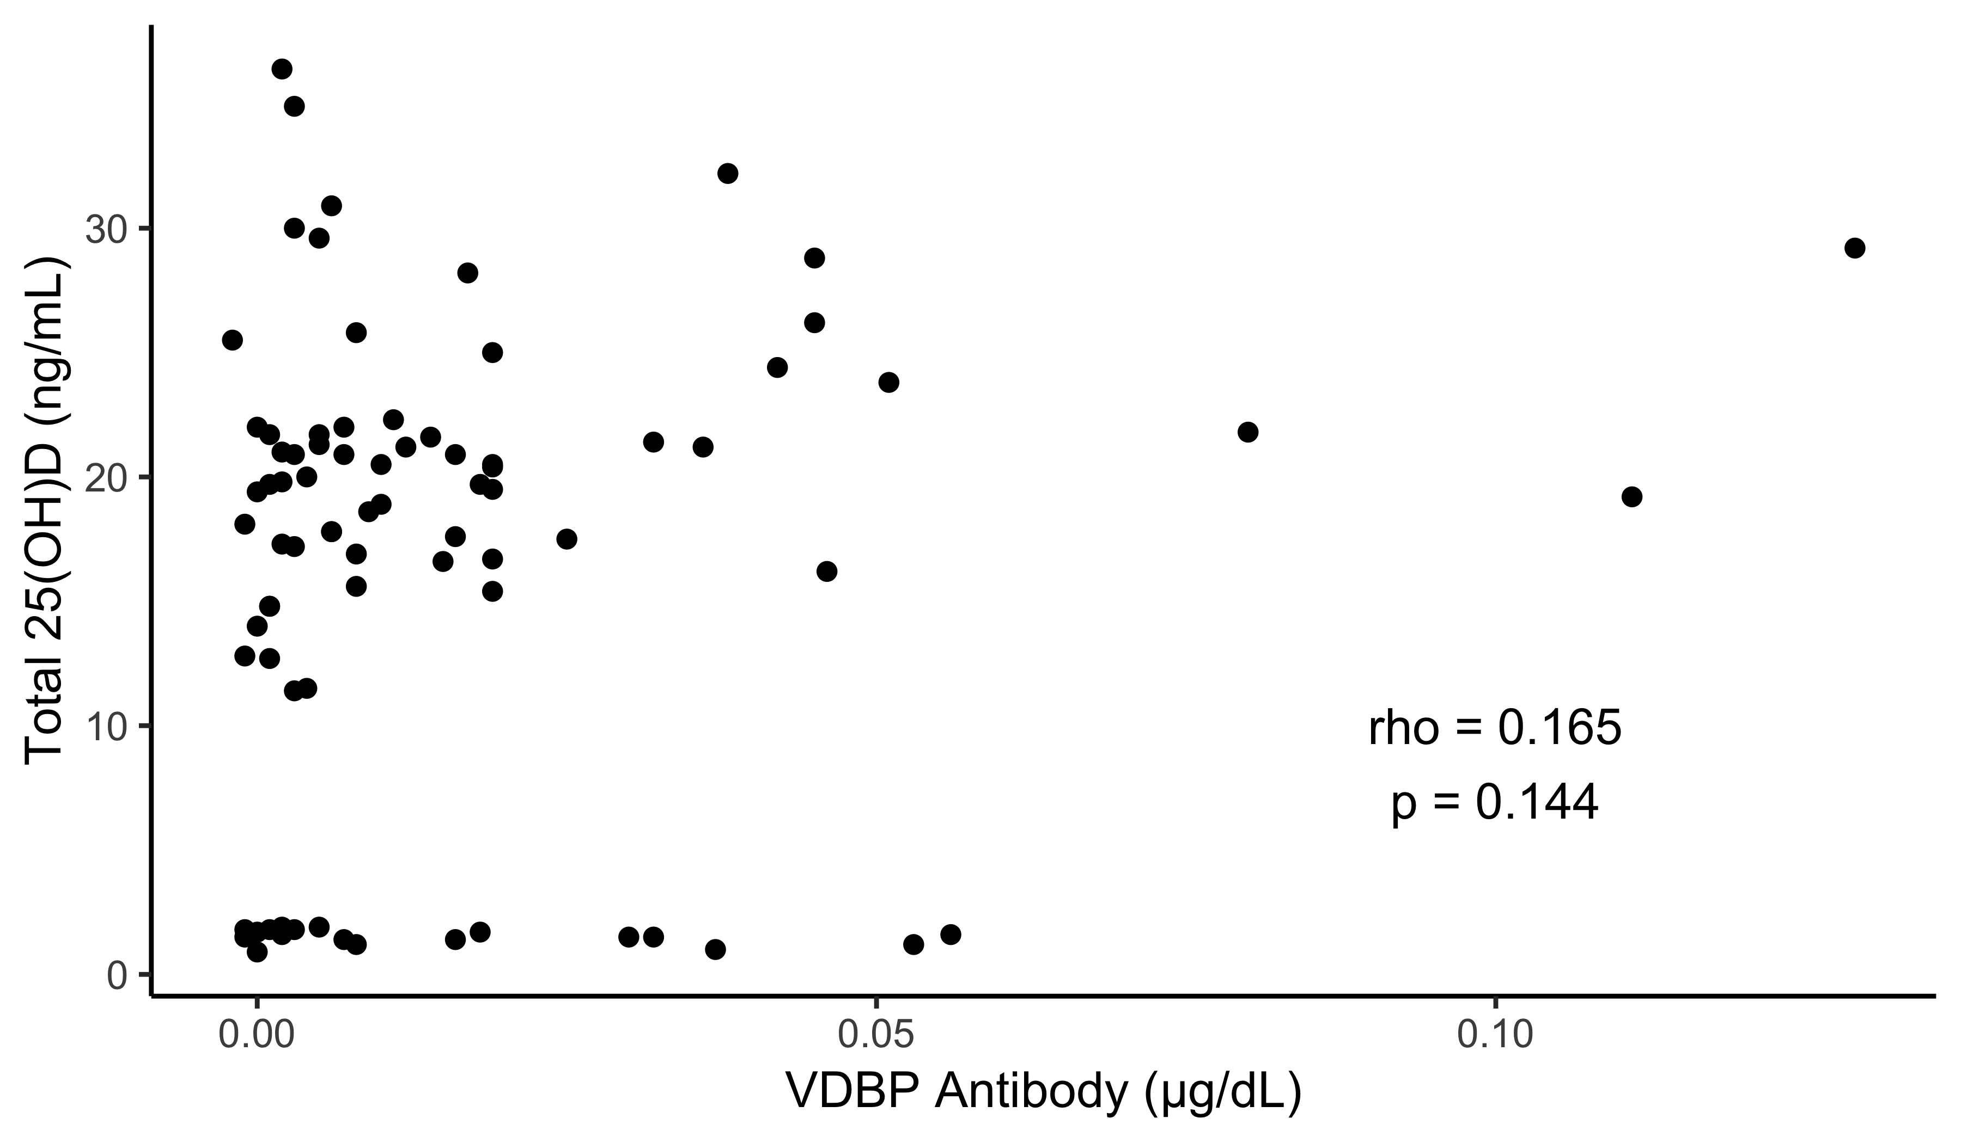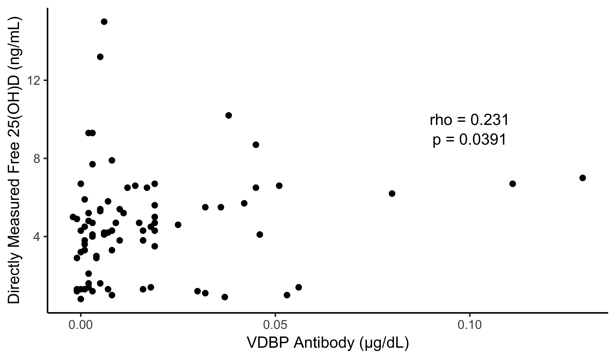

Figure 3: Interaction effects by antibody group

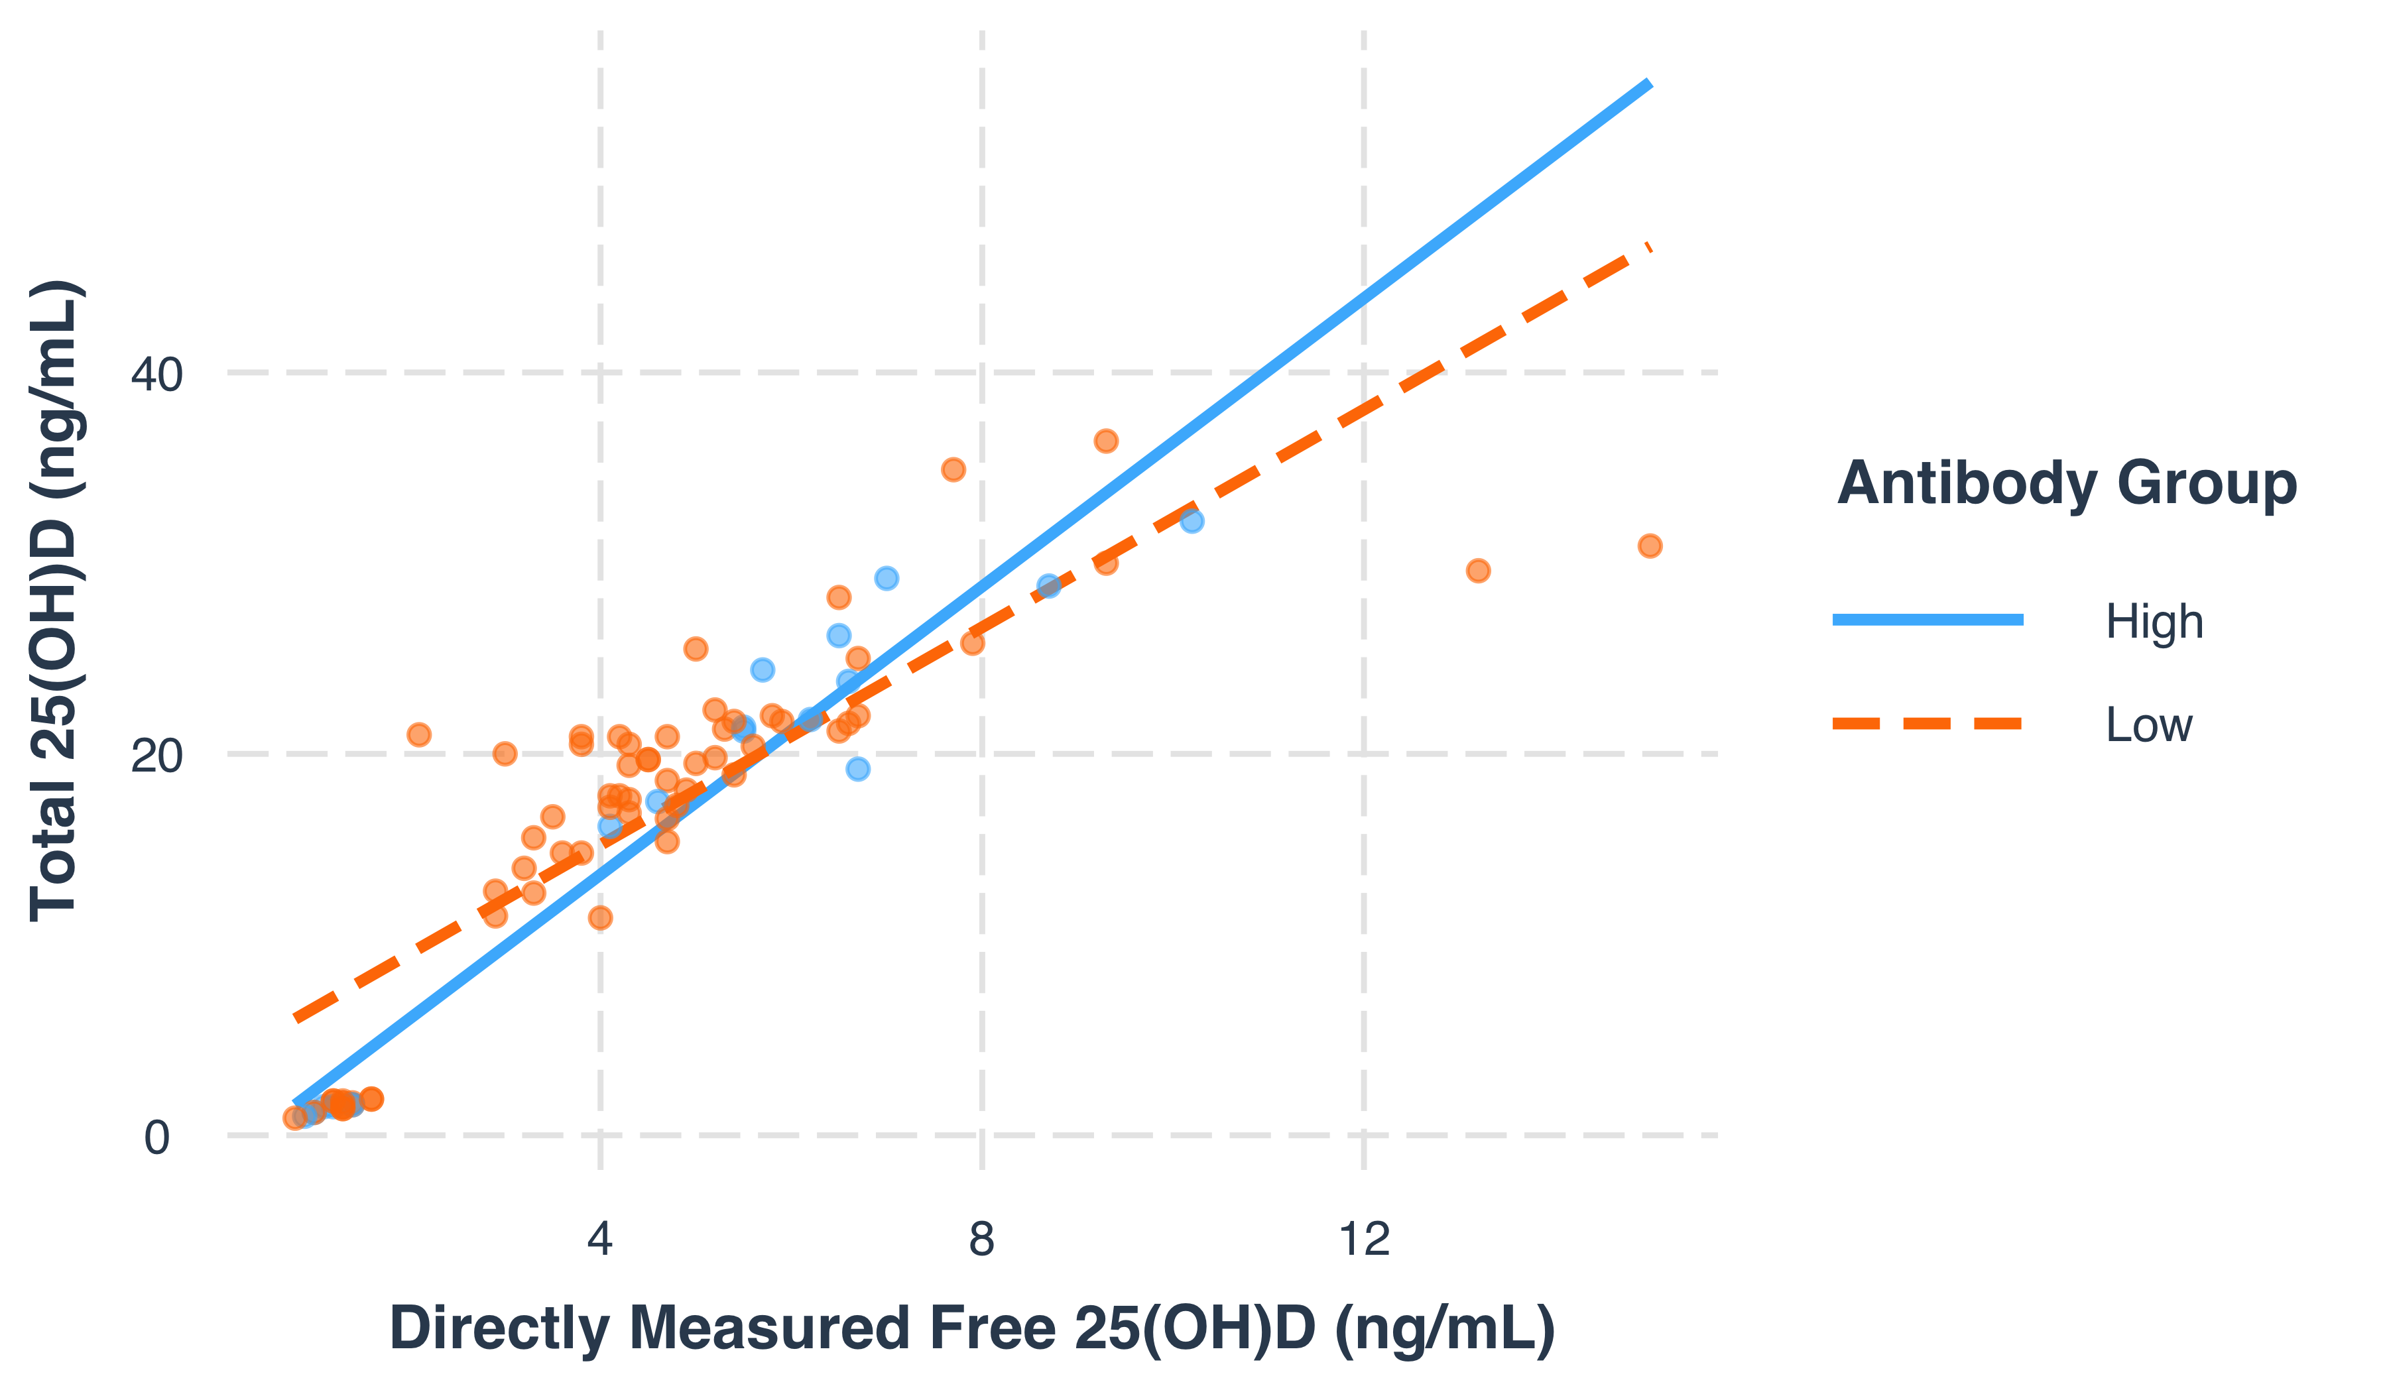

Table 2: Interaction Effects by Antibody Group

|  |  |  |  |  |
| --- | --- | --- | --- | --- |
|  | Estimate | Std. Error | t value | Pr(>|t|) |
| (Intercept) | -1.4391101 | 2.2588204 | -0.6371069 | 0.5259698 |
| Free Vit D | 3.7776221 | 0.4025574 | 9.3840582 | 0.0000000 |
| Low Antibody Group | 5.2552849 | 2.5281225 | 2.0787303 | 0.0410170 |
| Free Vit D:Low Antibody Group | -0.9246228 | 0.4583882 | -2.0171175 | 0.0472150 |

Table 3: Interaction Effects by Antibody Group, adjusted for age, BMI, and race

|  |  |  |  |  |
| --- | --- | --- | --- | --- |
|  | Estimate | Std. Error | t value | Pr(>|t|) |
| (Intercept) | 0.9783516 | 3.3998057 | 0.2877669 | 0.7743405 |
| Free Vit D | 3.8416960 | 0.4244598 | 9.0507886 | 0.0000000 |
| Low Antibody Group | 5.7263389 | 2.6693585 | 2.1452117 | 0.0352630 |
| Age | -0.0201052 | 0.0512406 | -0.3923676 | 0.6959299 |
| BMI | -0.1364841 | 0.1480411 | -0.9219343 | 0.3595998 |
| Race (Other) | -0.8530763 | 1.2251003 | -0.6963318 | 0.4884323 |
| Free Vit D:Low Antibody Group | -0.9204289 | 0.4835259 | -1.9035773 | 0.0609075 |